**Kathmandu University**

**Department of Computer Science and Engineering**

**Dhulikhel, Kavre**



**A Project Report**

**On**

**“SMART WARD”**

**[Course Code: COMP 206]**

(For the partial fulfillment of II year/I Semester in Computer Engineering)

**Submitted by:**

Shrawak Bhattarai (11)

Ramraj Chimouriya (14)

Deependra Kumar Gupta (18)

Shreyam Pokharel (40)

**Submitted to:**

Mr. Nabin Ghimire

Department of Computer Science and Engineering

**March 10, 2020**

**Bonafide Certificate**

This project work on

“SMART WARD”

is the bona fide work of

Shrawak Bhattarai, Ramraj Chimouriya, Deependra Kumar Gupta

and Shreyam Pokharel

who carried out the project work under my supervision.

**Project Supervisor:**

**________________________**

Mr. Pratit Raj Giri

Teaching Assistant

Department of Computer Science and Engineering

Kathmandu University

# Acknowledgement

Our project “SMARTWARD” would not have come this far without the invaluable contribution of 'Department of Computer Science and Engineering' who gave us the platform to explore new ideas and how to proceed further on our project.

We would like to express sincere gratitude to our project supervisor, Mr. Pratit Raj Giri, who has directed the execution of tasks in the project in a sequential and in an efficient manner. We would also like to thank our seniors and friends who helped us to setup the basic ideas and features in this project.

We would again thank all those who have assisted us in our project.

Sincerely,

Shrawak Bhattarai (11)

Ramraj Chimouriya (14)

Deependra Kumar Gupta (18)

Shreyam Pokharel (40)

# Abstract

People reach ward offices of their respective municipalities/ rural municipalities for their work on a daily basis. Whether it is for collecting certificates for vital registration activities or receiving recommendation letters for citizenship, people need to reach their concerned ward office for these works. This project aims to provide a common platform for various activities carried out in these offices.

This project stores data related to different vital registration in a local database and uses it for analyzing the status of a particular ward by analyzing various vital statistics on the basis of different parameters such as days, months and years using data visualization. Whether it is generating certificates for vital registration activities or analyzing data through graphs, this project can assist ward offices in all those activities.

This project uses PyQt5 package for the user interface, Python for back-end coding and MySQL database to store data, which can later be used to analyze and plan for different activities.

Thus, our project is a common platform for the aforementioned tasks which benefits the ward officials to conduct their task easily allowing effective implementation of their tasks.

**Keywords:** PyQt5, Python, MySQL, Data Visualization

**TABLE OF CONTENT**

Acknowledgement i

Abstract ii

List of Figures iii

List of Abbreviations iv

Chapter 1: Introduction 1

1.1. Background 1

1.2. Objectives 2

1.3. Motivation and Significance 2

Chapter 2: Related Works 4

Chapter 3: Design and Implementation 5

3.1. System Requirements Specification 8

3.1.1. Software Specification 8

3.1.2. Hardware Specification 8

Chapter 4: Discussion on the Achievements 9

Chapter 5: Conclusion and Recommendation 11

5.1. Limitations 11

5.2. Future Enhancements 12

References 13

Appendices 14

# List of Figures

Figure 1 Overall System Flowchart 7

Figure 2 Register Window 14

Figure 3 Main Window 14

Figure 4 Birth Registration Form 15

Figure 5 Birth Statistics Window 15

Figure 6 Marriage Certificate 16

Figure 7 Gantt chart 16

# List of Abbreviations

OS: Operating System

GUI: Graphical User Interface

PC: Personal Computer

IDE: Integrated Development Environment

UNICODE: Universal Coded Character Set

SQL: Structured Query Language

# ****Chapter 1: Introduction****

This project is aimed towards helping ward offices to keep records like vital registration details, provide recommendation letters, request for citizenships and request for copy of citizenships among others along with providing the facility of data evaluation using data visualization.

## 1.1. Background

The process of keeping record of vital human activities dates back to a very long period. Various methods have been introduced in an attempt to record these activities. These methods, in accordance with the conditions and time, have changed drastically through to the 21st century. Most of these activities took place with the help of paperwork while some have had the help of various modern techniques. Paperwork is considered to be one of the securest means of data protection, but having said that, the use of paperwork can be messy and leads to a lot of confusion. It can be more vulnerable if it is not handled properly. So, the process of keeping records can be challenging and time consuming.

Most of the ward offices in Nepal still use older techniques for handling and storing data which can later be analyzed in the future. There is no surety whether those activities are completed in time. Many files are found missing in such departments which can compromise the peoples’ trust in those departments and compromises the safety of the data. Even though some ward offices use spreadsheet software for storing data, they are limited to a certain extent and also do not serve their purpose. With the advent of new techniques and modern software it is relatively easier to perform these activities easily and securely. But still those softwares have been able to perform limited work.

Hence, considering the shortcomings of the aforementioned techniques or processes and addressing these typical real-life problems in these ward offices, this project is a pursuit in helping them store and analyze data using data visualization ,which can be used for better planning and implementation of projects accordingly in the future.

## 1.2. Objectives

The main objectives of this project are:

* To provide a digitized platform for replacing paperwork on ward offices.
* To help the ward departments visualize the certain records through which they will be able to carry out different programs in an efficient way.
* To facilitate the decision-making process of top management by furnishing the right information at the right time.

## 1.3. Motivation and Significance

Ward offices still use older techniques for storing data and carrying out their basic works. It is quite time consuming and tedious work to maintain and update those records with each new registration regularly. Although they still manage to do that over a short period of time, it becomes quite challenging once they cross a certain time barrier and require the use of smarter technique on the way along. Also, reviewing those records and grabbing the core aspects of those records to analyze the status of the ward is very challenging. This is quite a difficult job to keep the records and manage it in a manner as such to gain specific details from it for the activities performed by ward offices. Thus, this project is designed to help the ward officials to counter these problems.

This project could easily handle problems of collecting and storing records, which makes it way easier to use it for future reference. It uses a simple database that stores information fed by the admin through the various vital registration and recommendation forms. It generates registration certificates for the basic vital registration activities and the recommendation letters for the various recommendation activities. This allows people avoid the needless job of standing for hours waiting for these documents. It uses graph (curves) for representation of various vital statistics such as birth, death, marriage, divorce and migration on daily, monthly and yearly basis. It is relatively easier to make annual reports for municipality as well as for analyzing and comparing economic and social status of ward with great accuracy with the help of graphs. So, the use of graph could be a huge help to the ward officials.

# Chapter 2: Related Works

There are softwares for ward or municipal functionalities which can keep a record of population on different basis in a digitized way but those softwares are not able to visualize records and compare the number of records of that ward on a daily, monthly or yearly basis. Some of the works more or less resembling our projects are mentioned below:

Selvan, T. (2014) designed an automated system for Municipal Corporation whichused an E-based system to automate the related activities and store data.

Also, the Victoria Department of Justice and Community Safety use this sort of app for birth, death and Marriage registry. But this application is restricted to the client and also does not support data visualization.

Walker, C. (2015) designed a project “Gramps Genealogy Software” that aids in the birth, death and marriage registry and also in representing a family tree.

So, our project incorporates different aspects and ideas of the aforementioned softwares and projects to provide a common platform for these ward offices to carry out their work and not compromise the safety of the records that are handled out there. Also, we are implementing a new idea in our project that deals with data visualization which helps the departments analyze the records and perform their tasks accordingly.

# Chapter 3: Design and Implementation

A rough idea was sketched on how to start with the project and picked out the register window to be the starting point for out project development. Then the main window was singled out to be the nucleus of this project connecting all other windows and forms having basic features and also including all the menu and settings for the ward settings. The forms and the statistics window were then developed to carry out the basic operations of the ward.

Yes

No

Ward Registered?

C1

View Register Window

Create a pickle file for ward info

C1

Main Window

Home

Settings

Citizenship

Vital Regd.

Statistics

Birth regd.

Marriage regd.

Divorce regd.

Migration regd.

Death regd.

C2

C3

C4

C2

Update ward profile

Change password

Remove ward

Update registrar details

C3

Request for citizenship

Request for copy of citizenship

C4

View migration statistics

View divorce statistics

View marriage statistics

View death statistics

View birth statistics

Figure 1 Overall System Flowchart

## 3.1. System Requirements Specification

### 3.1.1. Software Specification

#### 3.1.1.1. Front End Tools

PyQt5 is a free and open source Python library/ package for developing Desktop GUI that provides various classes for creating a user interface. During this project, VS Code was considered for editing and testing the codes.

#### 3.1.1.2. Back End Tools

The backend of this project is the actual program containing libraries, functions, classes and other entities based on Python3. Subplot of Python library matplotlib is used for data visualization. The codes use variables and dictionaries that consume memory in RAM to make our website functional and responsive. The information is managed with the help of MySQL using Xampp Server that provides local server for managing databases.

### 3.1.2. Hardware Specification

This project is a simple application with some features resembling a management application, though sophisticated hardware is not required. Any modern PC capable of running a modern OS is sufficient to run the program smoothly.

# Chapter 4: Discussion on the Achievements

Connection to the database is an integral element in our project. More than half of our project uses database to perform certain task. There was no problem in connecting the main program to the database directly. The certificate was completed successfully albeit some minor error was encountered which was resolved by meeting the target file in the specified target folder.

This project includes certain features of data visualization. The standard library for plotting graph, for data visualization, was a bit harder to integrate to the main window of this application. So it uses the subplot of the standard library for plotting the graph. Also it encountered problem while running the window while plotting graph for different parameters. It was solved by changing the central widget of the window as the parameter changed. It encountered problem while connecting multiple windows which was cleared through using relative importing which solved the problem of missing target file in the specified target folder and also helped to manage the program files effectively. It required creating an instance of the child window from parent window to connect the multiple windows in this application.

Thus, the project was completed effectively finding the solution for the each of the problems encountered during this project.

**Features:**

After a ward department gets registered and logged in the system, main window can be accessed and records of birth, death, migration, divorce, marriage and many more ward works by taking the data of the concerned person can be stored in the local database. The ward registration can happen only once and after that whenever the application is run, the main window is directly accessed. This project can visualize records and also can compare the number of records of that ward on a daily, monthly and yearly basis. This application also allows the ward offices to change their profile which includes changing of their name, ward number and logo among others. It also generates certificates and recommendation letter of the concerned works.

# Chapter 5: Conclusion and Recommendation

Overall, most of the features intended to include were completed. Implementation of the features such as vital registration, recommendation and data visualization are successfully completed.

The feature such as vital registration was completed using a simple database by storing all the required information from the client and issuing a certificate of the concerned registration. Recommendation letters were provided from the details supplied through the recommendation forms. Data visualization was too successfully implemented using data supplied during vital registration.

The limited time and lack of practical skills restricted the project to an admin-based desktop application for the use of ward officials as opposed to the proposed project with an additional client-based web application that served for the users to carry out the same works individually from their homes. The validation of information during registration could not be as powerful as intended.

This application incorporates all the major objectives of this project. The features in this project can be further enhanced by making some modifications to these in the future.

## 5.1. Limitations

* This application is available only to Windows/Linux users.
* This application can only access the local database and not the external servers for storing records.
* This application has typically an admin-based interface only.
* This application requires Wi-Fi connection for email validation of ward registration.
* This application does not have full proof validation of data entered during vital registration.

## 5.2. Future Enhancements

* To make the application available in other operating systems, the same can be re-used and develop new programs with suitable compatibility.
* Using an online server for remote database access.
* A website version of this project can be added in order to increase the feasibility of the project as well as for a client-based interface.
* A full proof validation mechanism and enhancement in data amending process can be implemented in the future.

# References

# Appendices

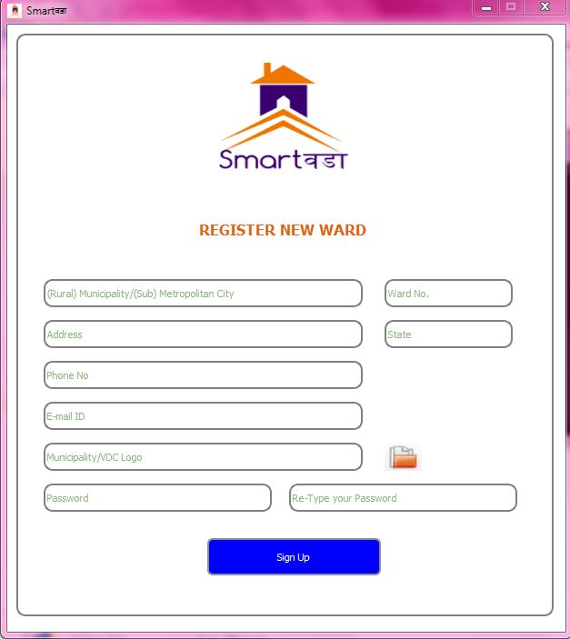

Figure 2 Register Window

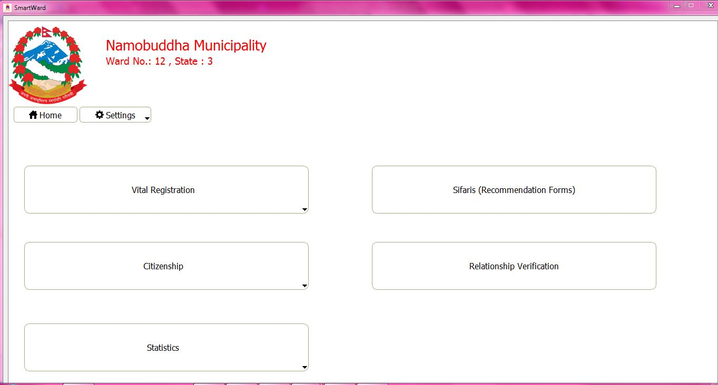

Figure 3 Main Window

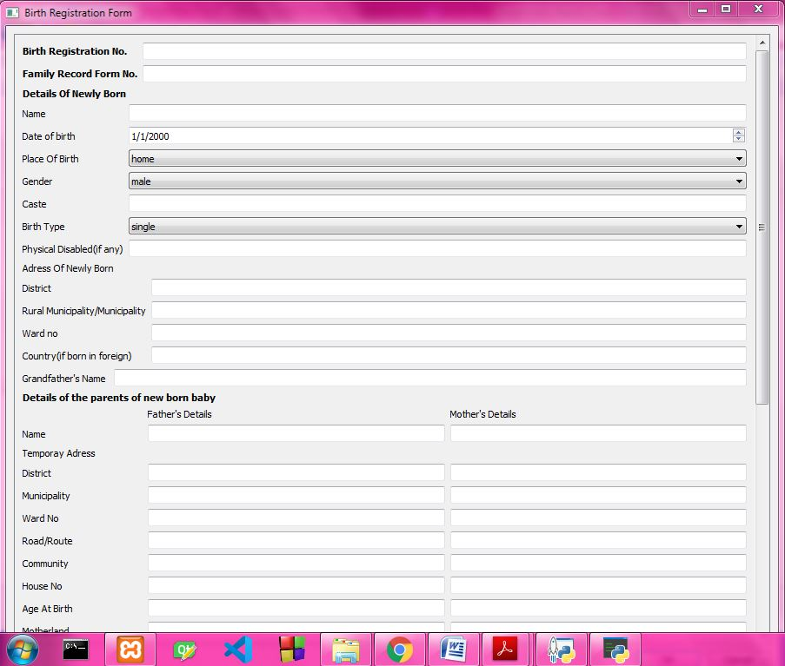

Figure 4 Birth Registration Form

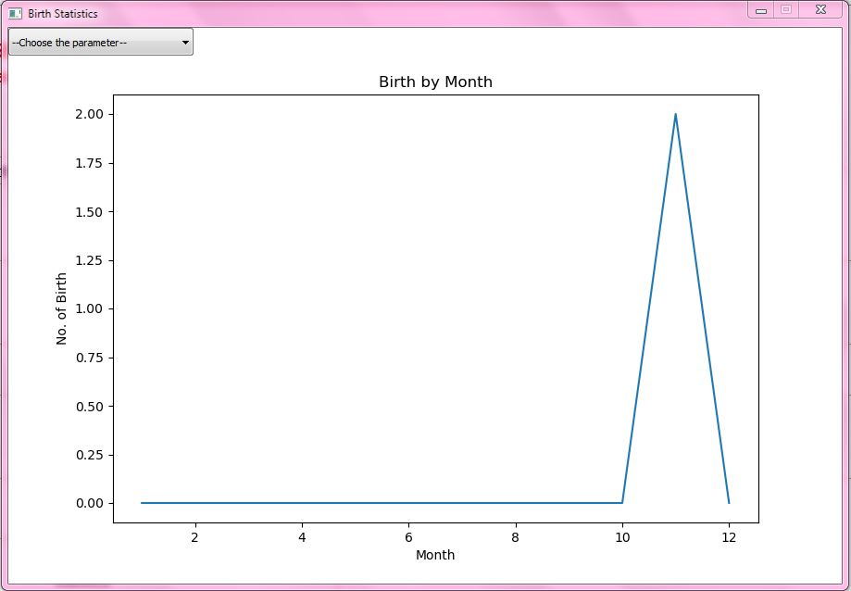

Figure 5 Birth Statistics Window

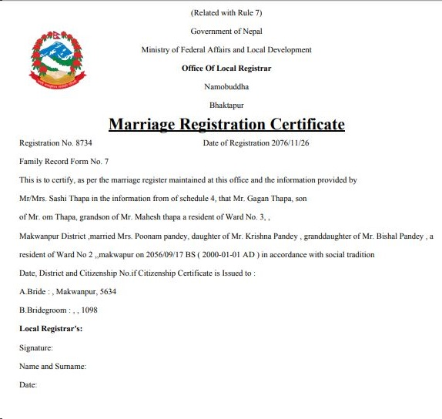

Figure 6 Marriage Certificate

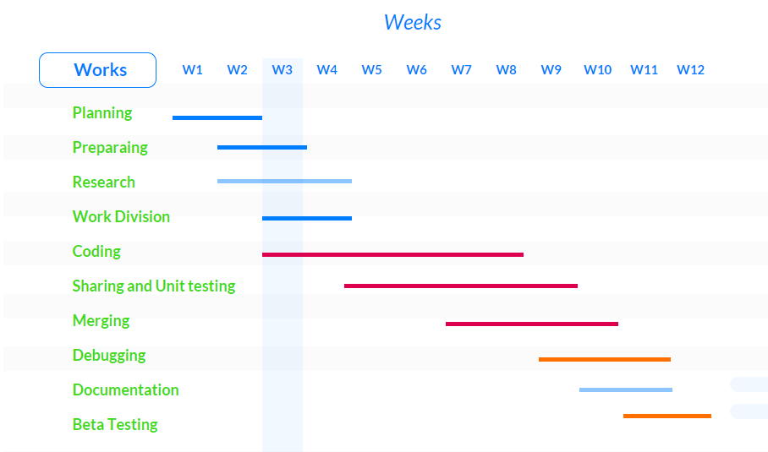

Figure 7 Gantt chart